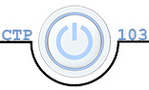**Julia Kovrigin**  **CTP 103**

# Lab 9: Using Basic Operating System Features (26 points)

Objectives:

* Use operating system tools in both the GUI and CLI
* Virtualization: use and set up

##### Section I: Investigating storage devices using the GUI and CLI– 10 points

Instructions are provided for Windows 10 and Mac OS X. Use the instructions for the platform you are using, i.e. if you are using Windows 10, skip the sections that give instructions for MAC OS X, and vice versa. ***Note: GUI is Graphical User Interface; CLI is Command Line Interface.***

**Windows 10**

1. Determine your computer’s **storage devices using the GUI**.
   1. Windows: Open File Explorer by clicking on the File Explorer icon on the Task bar
   2. Select **This PC** on the Ribbon select **View** and in the **Layout** group choose Tiles
   3. List all of your **storage devices**, including size and space available. Note that these are listed under Devices and Drives. ***Note: do not include USB drives.***

|  |  |  |
| --- | --- | --- |
| **Drive Letter/Name** | **Total size** | **Available space** |
| C: | 939 GB | 758 GB |
|  |  |  |
|  |  |  |
|  |  |  |
|  |  |  |

1. Determine your computer’s storage devices using the CLI
   1. Open the Command Prompt window:
   2. Type **Command** in the Search box on the Task bar. Select “**Command Prompt**” when it appears on your screen.
   3. By default, the Command Prompt accesses C:\Users\Your Name. (Please notice that this is the “back slash “\” (the key above the Enter key and not the forward slash “/” (the key to the left of the Shift key and what you use in Web addresses).
   4. To get to the access the root directory, type **cd\** -- then **Enter**

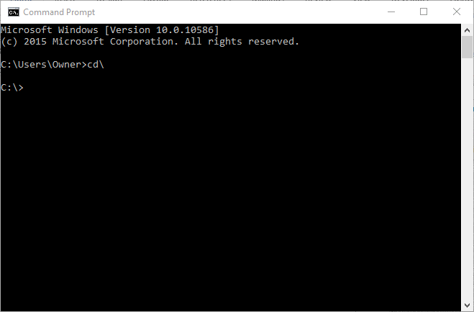

1. You should see a window like the one above. The **C:\>** means you are at the root directory of the C drive.
2. The greater than symbol, **>**, is called the prompt. This means that the computer is ready and waiting for you to type in a command. It is “prompting” you.
3. View storage devices using the diskpart tool, type: **diskpart** then **Ente**r
4. Select **Yes** if the User Access Control window opens
5. In the DiskPart window type: **list volume**
6. This list should have the same items that you found using the GUI in Step 1 above. Here is my example:

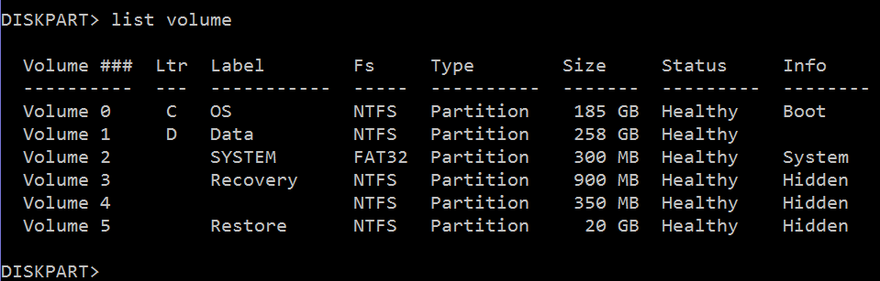

1. Close the DISKPART window

**Mac OS X**

1. Determine your computer’s storage devices using the GUI
   1. Click on the Apple menu  in the upper left corner of the screen
   2. Select About This Mac
   3. Select the Storage tab
   4. List all the hard drives on your system

|  |  |  |
| --- | --- | --- |
| **Disk Name** | **Free space** | **Total space** |
|  |  |  |
|  |  |  |
|  |  |  |
|  |  |  |

1. Determine your computer’s storage devices using the terminal window (Note: OS X is a Linux bases system and thus commands and file names are case sensitive.)
   1. Open a Terminal Window
   2. Open Finder
   3. Click on Applications
   4. Expand Utilities
   5. Double click on **Terminal**
   6. Enter the command: diskutil info /
   7. Scroll down to see the Total size and Free space. They should be the same as the answer you got in step 1d above.

##### Section II: Discovering System Properties using the GUI and CLI– 10 points

Instructions are provided for Windows 10 and Mac OS X. Use the instructions for the platform you are using.

**Windows 10**

1. Discover your system properties using the GUI
   1. Type **System** on the search box on the Task bar and select **System**.
   2. Describe your computer using the table below.

|  |  |
| --- | --- |
| OS Name (Windows Edition) | Windows 10 Home |
| System Name | SER-JUL01 |
| System Type | 64-bit Operating System, x64-based processor |
| Processor including clock speed | Intel Core i7-7700HQ CPU @ 2.80GHz |
| Installed Physical Memory | 16.0 GB |

1. Discover your system properties using the CLI
   1. At the command prompt window type: **systeminfo**
   2. Identify the names for the items in this display that are equivalent to the information in item b above. The first one is done for you.

|  |  |
| --- | --- |
| OS Name (Windows Edition) | Microsoft Windows 10 Home |
| Host Name (same as System Name) | SER-JUL01 |
| System Type | x64-based PC |
| Processor including clock speed | Intel64 Family 6 Model 158 Stepping 9 GenuineIntel ~800Mhz |
| Total Physical Memory (same as Installed Physical Memory) | 16,236 MB |

**Mac OS X**

1. Discover your system properties using the GUI
   1. Click on the Apple menu  in the upper left corner of the screen
   2. Select About This Mac
   3. Make sure the Overview tab is selected
   4. Describe your computer using the table below.

|  |  |
| --- | --- |
| Mac OS X Edition and version |  |
| Processor including clock speed |  |
| Memory |  |

1. Discover your system properties using the Terminal Window
   1. Open a Terminal Window
   2. Enter the command: **sw_vers**
   3. What is the Product Version for this Mac OS X installation? Click here to answer.
   4. Enter the command: **system_profiler SPHardwareDataType**
   5. You should see the information that you recorded in rows 2 and 3 of the table above.

##### Section III – Virtual Machine using VMware – 6 points

Read the article: [How to Create and Use Virtual Machines](https://www.howtogeek.com/196060/beginner-geek-how-to-create-and-use-virtual-machines/) and watch the video: [Create a Virtual Machine in VMware Workstation Pro.](https://youtu.be/BHpRTVP8upg)

1. What is a virtual machine? (1 point) A VM is a software that you download on your computer that allows you to simulate and experience other OS without actually having then on your machine.
2. What can you do with a virtual machine? Give examples (2 points) With a VM you can you can run apps that are not available to run on your current OS as well as running multiple VMs.
3. What are a virtual machine’s limitations? Give examples (2 points) The limitations of a VM are they are not as fast as real hardware installed and also not ideal for gaming.
4. In the video, what operating system is being installed? (1 point) Linux version Ubuntu 64-bit

Submission Instructions

1. Make sure you have entered your name and section number at the top of the document.
2. Save the document as **YourLastName_Lab9.docx**, replacing YourLastName with YOUR last name.
3. Submit the assignment to the Lab 9 dropbox in Canvas by the due date.